1. In the earlier lecture, we noticed that we can do the transformation using two ways.
   1. **transformation()**:
   2. **Using bean(<bean>)**: whose method will be called, and that method return some value as part of transformation.
2. Similarly, we can do processing two ways. One way we already discussed in the earlier lecture.
   1. **Using bean(<bean>)**: Whose method will be called, and that method will not return any value. Means method’s return type is void.  
      This we discussed already in the previous lecture.
   2. Using Processor interface: Let’s discuss this.
3. **NOTE**: If you’re familiar with Spring Boot, then you will probably go for bean() for both transformation & processing.

Processor:

1. 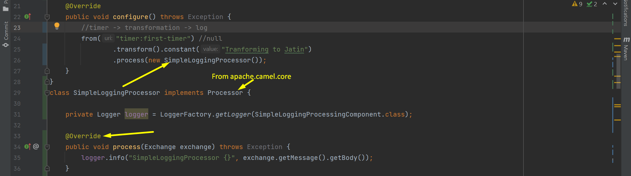
2. Nothing special related to end-result.   
   The only thing here is that void **Processor.process(Exchange)** will be called.
3. Till now we’re playing with simple endpoints like timer & log.  
   In next lecture, let’s play with file as an endpoint.